16th May 2023

Dear Parent/Carer

**Young Minds Matter – Parent’s Information Session**

**Young Minds Matter (YMM) is a safe and confidential mental health support service developed for children and young people up to 18 years of age in schools across Gloucestershire. The organisation offers a range of support for young people in our school as well as providing helpful tools and resources online including their YMM Chat service. More information can be found here:** [Young Minds Matter > Glos Health & Care NHS Foundation Trust (ghc.nhs.uk)](https://www.ghc.nhs.uk/our-teams-and-services/cyp-glos/young-minds-matter/)

**On Wednesday 24th May 2023 5pm-6pm we will be hosting a YMM parent information event. At this event we will be presenting a general overview of YMM and what they can offer including the difficulties they support with. They will also be providing parents with some resources for supporting child mental health, as well as information and guidance.**

**The session is free to attend, and complimentary tea and coffee will be available. If you think you can make the session, please turn up to the school from 4:45pm for a 5pm start.**

**I look forward to seeing you then.**

Yours sincerely

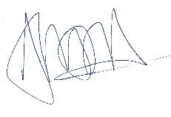

**Mr A Hara**

**Assistant Head Teacher (Student Welfare & Guidance)**