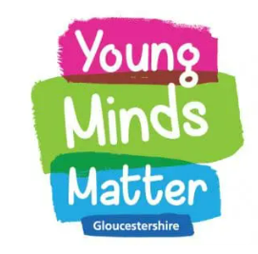

Maidenhill School works in partnership with Young Minds Matter.
Young Minds Matter is a safe, confidential mental health support service for school-aged young people. They are part of the Gloucestershire NHS Child & Adolescent Mental Health Service (CAMHS) and a national scheme of Mental Health Support Teams (MHSTs).
How can Young Minds Matter help?
Young Minds Matter is an early intervention team who can support young people who are experiencing mild to moderate mental health difficulties. They can help with things like:
- Worries
- Negative thoughts
- Anxiety
- Low Mood
- Low self-esteem
- Friendship difficulties stemming from anxiety or low mood
- Low level self-harm or suicidal thoughts.
- Exam Stress
Young Minds Matter mainly uses a type of therapy called Low-Intensity Cognitive Behavioural Therapy, which helps young people to think about how their thoughts (cognitions) impact on their actions (behaviours) and their feelings (emotions). There are tasks to complete between sessions to help the young person practice the skills they are learning. There are also other members of the team that provide other CBT-informed interventions.
Young Minds Matter does not offer counselling, and sessions are based on supporting a young person with achieving a specific goal by understanding more about their mental health and strategies they can use to achieve the goal.
How to access support
Young People can refer themselves to Young Minds Matter using YMM Chat. YMM Chat is a text-only number where a young person will text with a member of the Young Minds Matter team. The textline is open 9am until 4:30pm, Monday-Friday (except bank holidays). They don’t need consent from school or parents/carers.
YMM Chat: 07480 635723 (Monday to Friday 9am – 4:30pm)
YMM Chat is not a self-referral route for parents and carers.
If a pupil does not want to self-refer, they can also speak with Mr. A Hara who will be happy to support them with this.
If for any reason a pupil doesn’t feel comfortable self-referring or speaking to Mr. A Hara then parents and carers can access a referral through On Your Mind Glos (www.onyourmindglos.nhs.uk).
What else does Young Minds Matter do in our school?
Young Minds Matter also comes in to school to deliver assemblies, workshops and small groups on a range of wellbeing topics such as Transition, Understanding Emotions and Exam Stress. A member of the Young Minds Matter team also meets with us regularly to talk about what other support is available. If you would like us to discuss your child with someone from Young Minds Matter, then let us know by contacting Mr. A Hara

